**Muhammad Nasyith Aditya Putera**

**4342411060  
TRPL 1B Malam**

**PRAKTIKUM 7**

**Framework Bootstrap (Layout, Mock Up)**

1. **Layout.html**

**Kode Program :**

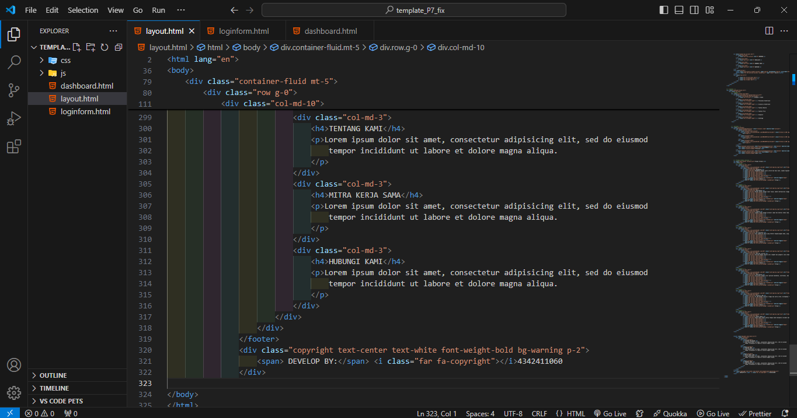

**Hasil :**

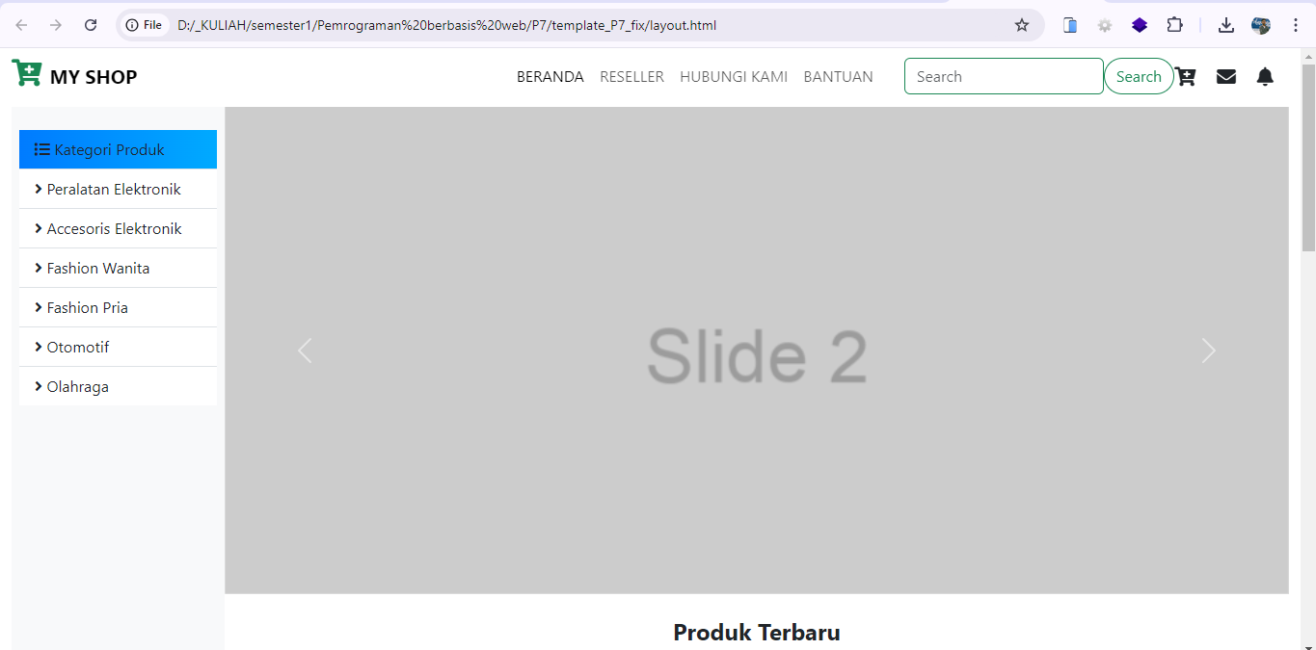

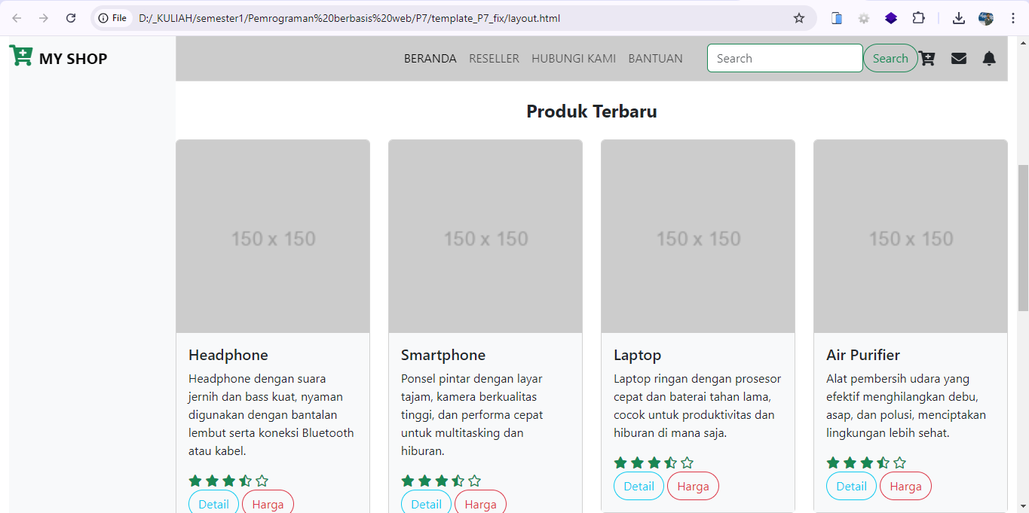

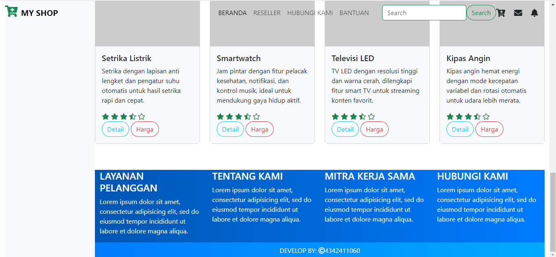

1. **Loginform.html**

**Kode Program :**

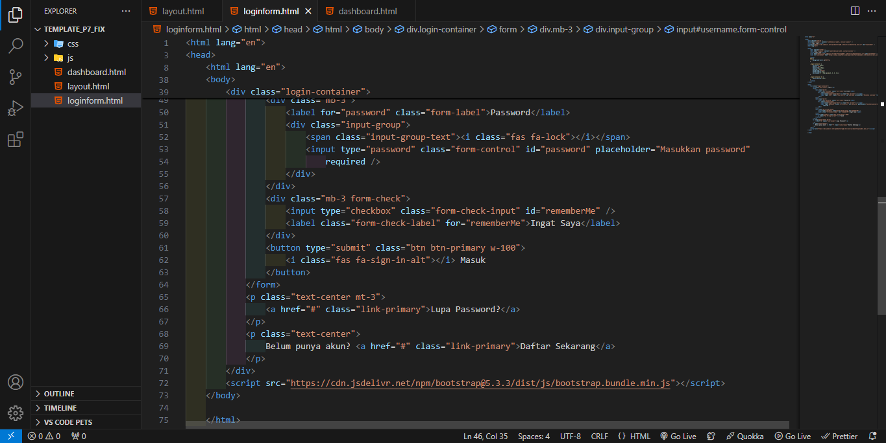

**Hasil :**

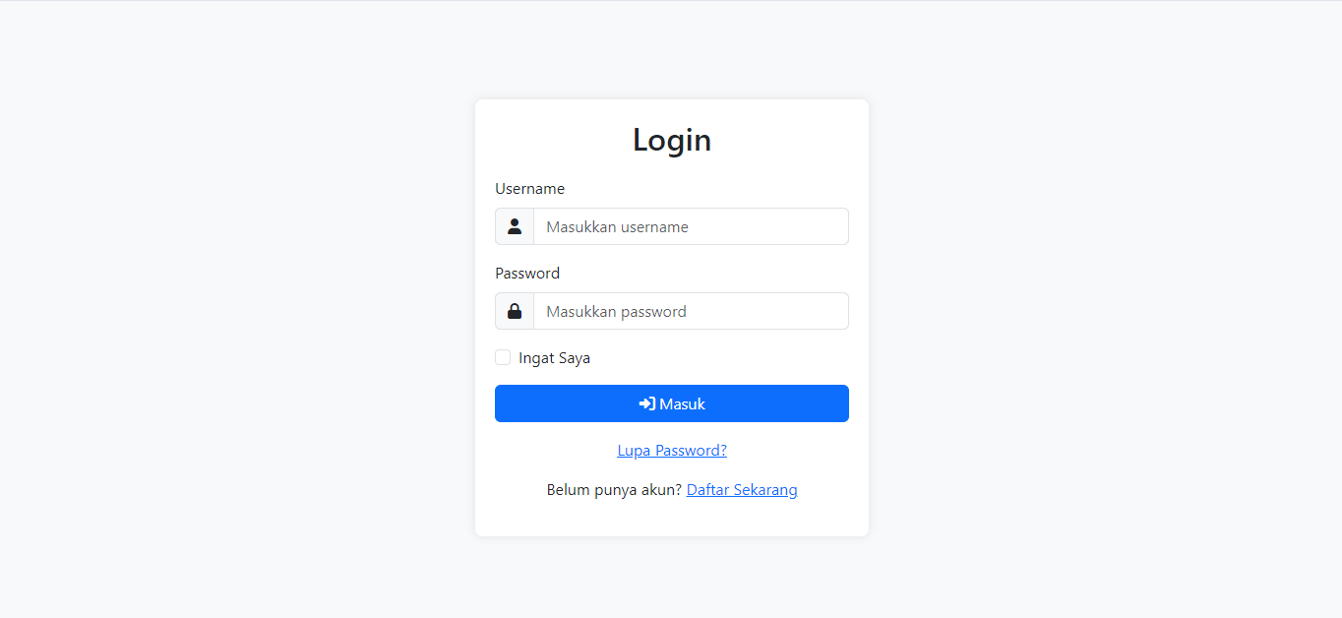

1. **Dashboard.html**

**Kode Program :**

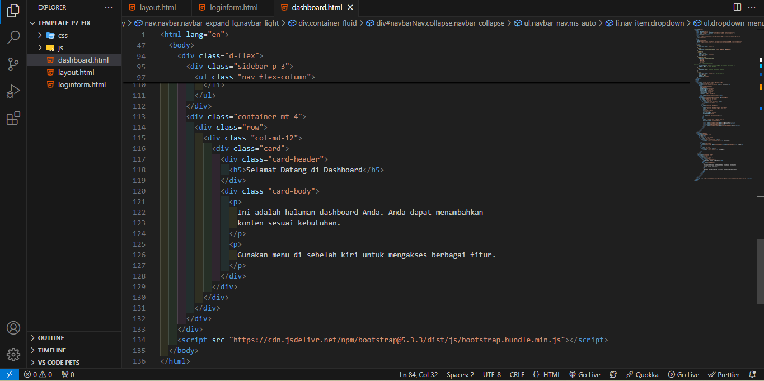

**Hasil :**

